RBMIC Biological H&E and Fluorescence Image Registration Software V1.0
User Manual

Table of Contents
- Software Introduction
- Image Preprocessing Tool
2.1 Usage
2.2 Function Description
- Image Coordinate Clicking Tool
3.1 Usage
3.2 Function Description
- Dual-Image Registration Tool
4.1 Usage
4.2 Function Description
- Affine Transformation Tool
5.1 Usage
5.2 Function Description
- Software Performance
- System Requirements
- Supported Software

1. Software Introduction
The RBMIC Biological HE and Fluorescence Image Registration Software is designed for cell-level alignment of Hematoxylin & Eosin (HE) and fluorescence images. Written in Python, this tool addresses the challenge of precise cell-to-cell registration by allowing users to manually mark matching cell pairs. This significantly enhances registration accuracy compared to conventional methods.

2. Image Preprocessing Tool

2.1 Usage
- Run before.py.
- Input the paths of the two images.
- Enter preprocessing parameters as prompted.
Default Settings: Enter 0 for all parameters unless adjustments are required.
Adjustments: If the region of interest (ROI) is off-center (e.g., located at a corner), input the approximate deviation distance (e.g., "left/right offset").

2.2 Function Description
Before.py is a Python script for image preprocessing. It imports necessary libraries, defines image processing functions, and executes tasks via the main() function.

3. Image Coordinate Clicking Tool

3.1 Usage
- After preprocessing, run image_clicker.py for both images.
- Input the image paths and mark at least two corresponding cell coordinates on each image.
- A window will display the image. Click to mark points, and the coordinates will be recorded.
- Close the window by entering no after marking. To save the image, enter yes.
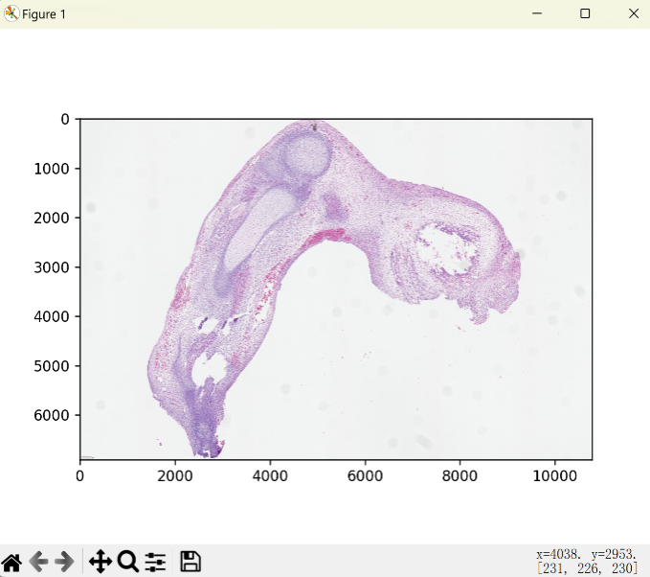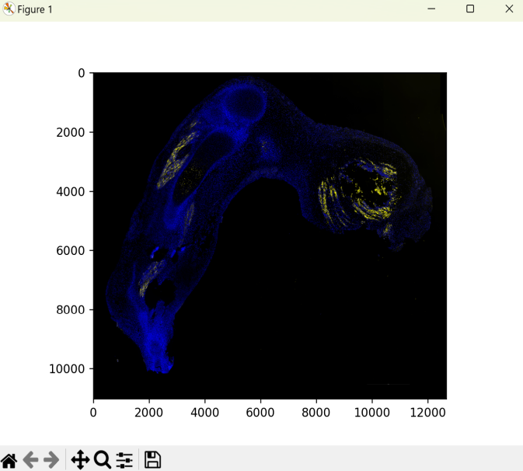
Figure 1: Example of Point Marking Interface
3.2 Function Description <a name="functions-clicking"></a>
image_clicker.py enables interactive coordinate selection and saves regions of interest (ROIs).

4. Image Registration Tool

4.1 Usage <a name="usage-registration"></a>
- Run full.py or full1.py.
- Input the image paths and the four marked coordinates.
- The registration process will display in the console.
- Results are saved automatically upon completion.
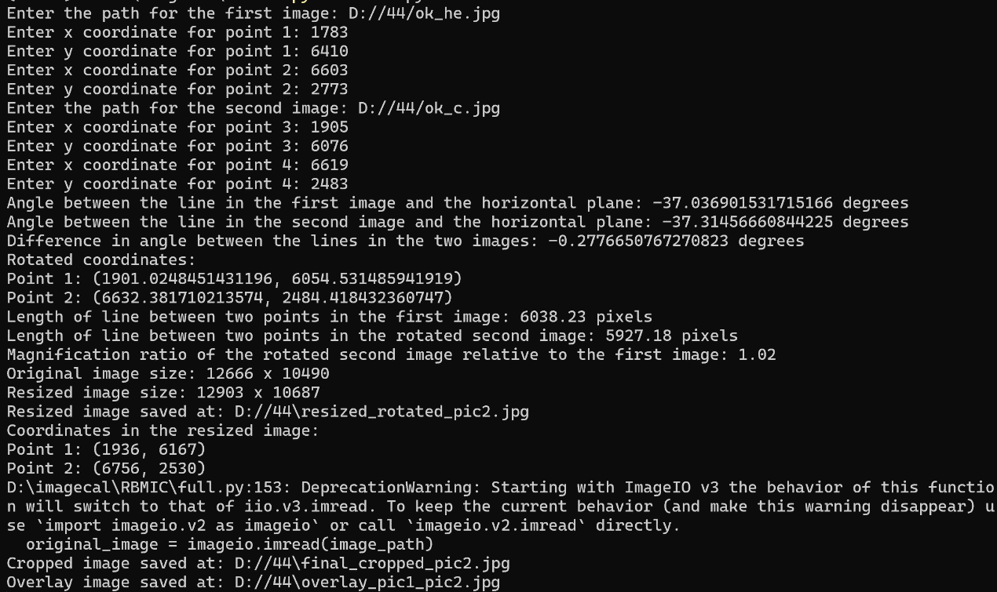
Figure 2: Registration Process and Output

4.2 Function Description
The script performs:
- Angle and length ratio calculations.
- Image resizing, cropping, and alignment.
- Image overlay for result verification.
- Edge correction via affine transformation if needed.

5. Affine Transformation Tool

5.1 Usage
- Run image_clicker.py again to mark four edge points on both images (ensure points cover the entire shape).
- Process full.py Output. Input the image generated after running full.py.
Mark the same four edge points in the same positions as before and record their coordinates.
- Run distory_image.py and input the image paths and eight edge coordinates.
- The transformed image and overlay result are saved automatically.

5.2 Function Description

This code implements image perspective transformation and overlay visualization, featuring an interactive interface for inputting image paths and keypoint coordinates. Below is a detailed breakdown of each module and its functionality:
Main Program
5.2.1. Input Parameters via Interactive Interface
Users input the file paths of the source image and target image, along with their corresponding keypoint coordinates.
5.2.2. Calculate Perspective Transformation Matrix
The matrix is computed using OpenCV’s cv2.getPerspectiveTransform function.
5.2.3. Apply Perspective Transformation
The matrix transforms the source image’s perspective to align with the target image.
5.2.4. Save Transformed Image
The output is saved as distorted_image.jpg.
5.2.5. Overlay and Save Result
The transformed image is overlaid onto the target image, and the combined result is saved.
5.2.6. Display Overlayed Image
The final result is displayed for visual verification.
5.2.7. Additional Functionality: Localized Analysis
To extract a specific region from the registered image (e.g., distorted_image.jpg):
1.Run image_crop.py.
2.Input the file path of the registered image.
3.The selected region will be captured and saved to the same directory as the original image.
Note: Ensure all input coordinates are entered in the correct order to guarantee accurate transformation and alignment.
.

6. Software Performance
Metric | Specification
Response Time | ≤10 minutes per operation
Accuracy | All functions execute correctly
Robustness | Error handling for user mistakes; system remains stable
Reliability | 24/7 operation without failure
Efficiency | Smooth execution under normal workloads
Usability | Intuitive commands and parameters
Clarity | Clear workflow and prompts
Scalability | Modular design for future upgrades
Compatibility | No special requirements
Portability | No special requirements

7. System Requirements
- Hardware:
Minimum: 8GB RAM, 256GB HDD.
- Operating Systems:
Windows 7/8/10, Linux (Ubuntu), Mac OS.

8. Supported Software
Software | Version | Vendor | Purpose
Operating system | Windows 7/8/10 | Microsoft | System Management
 | Linux (Ubuntu) | Canonical
 | macOS | Apple
Programming | Python (≥3.6) | Python Software | Execution Environment

Note: For partial analysis of registered images, run image_crop.py and input the path of the final output image. Cropped sections will be saved automatically.

